**COLLABORATIVE PROJECT WITH INTEL**

**PROJECT TITLE : COMMON INTEGRATED SERVICES TO COMMON PEOPLE – AI IN TRANSPORTATION**

**TEAM NAME :** **SHADOWGALE**

**Team Mentor : Dr T V RAJINI KANTH, Professor & Head,**

**Department of CSE-AI&ML**

[**rajinikanth.t@sreenidhi.edu.in**](mailto:rajinikanth.t@sreenidhi.edu.in)

**Ph. No: 9849414375**

**Team Members : K.Spoorthy** Roll no: 22311A6675 AIML Team lead

**E.Madhuri** Roll no: 22311A6693 AIML Team member

**J.Vanshitha** Roll no: 22311A6613 AIML Team member

**K.Surya Vamshi** Roll no: 22311A6627 AIML Team member

**Institute Name** **:** **Sreenidhi Institute of Science and Technology**

**Yamnampet, Ghatkesar**

**Hyderabad - 501301**

**Date of submission :** **15-07- 2024**

**ABSTRACT:** AI – driven Websites and Chatbots has revolutionized the transportation sector, enhancing user experiences and operational efficiencies. These systems provide comprehensive information on car features and models, aiding users in making informed decisions based on their preferences and budget. They efficiently resolve vehicle-related inquiries, including technical issues and maintenance concerns, ensuring effective customer support. In insurance, AI Chabot’s recommend suitable companies and policies, reducing fraud risks. They offer real-time updates on traffic and road closures, optimizing travel plans and minimizing disruptions. By issuing proactive safety alerts for accident-prone areas, they help prevent accidents and promote safer driving practices. Additionally, their vehicle tracking capabilities allow users to monitor their vehicle’s status and location, enhancing security and providing peace of mind. Overall, AI Chatbots act as comprehensive support systems in transportation, delivering personalized assistance, improving safety measures, and streamlining vehicle management, marking a significant advance towards intelligent and user-centric transportation solutions.

**INTRODUCTION**

Artificial Intelligence (AI) has fundamentally reshaped the transportation sector, introducing innovative solutions to meet the evolving needs of users and businesses. Among these advancements, AI-driven Chatbot’s have emerged as indispensable tools, offering a myriad of benefits and functionalities. From providing detailed information on car features to resolving queries and enhancing safety, these intelligent systems empower users and streamline vehicle management processes. As technology evolves, these Chatbot’s play a pivotal role in shaping the future of transportation. The functions that revolve around this Web site/ Chatbot involve:

* Real-Time Updates and Safety

It also provides services like:

* Transportation Services
* Nearest Vehicle Service Centers
* On-Spot Vehicle Service Contacts
* Buy/Sell Vehicles

**MOTIVATION**

The motivation for studying AI in Transportation is AI systems can predict and respond to hazardous situations more quickly and accurately than human drivers, significantly reducing the risk of accidents. Additionally, AI promises to improve traffic management and reduce congestion through intelligent traffic light control and route optimization, leading to more efficient use of infrastructure and reduced travel times. Moreover, the adoption of AI in transportation can lead to substantial economic benefits by lowering operational costs through predictive maintenance and optimizing fuel consumption.

The Intel Industrial Training initiative Unnati Program helps the students in getting the flavour of Industrial View of the work planning, interaction and guidance of Intel Team and friendly competing with other college students.

**DATA SOURCES**

Downloaded and analysed the Car dataset from Kaggle and studied on various existing models.

Developed code to take the input as Car model and generates output as all the cars available in that model.

Developed a program to take Selling price range and milage as input and identifies the cars available.

**PYTHON LIBRARIES USED IN THE PROGRAMS**

**Streamlit**: The primary library to create the web application interface.

**Pandas**: For data manipulation and analysis.

**NumPy**: For numerical operations and handling arrays.

**Scikit-learn**: For implementing machine learning models.

**TensorFlow or PyTorch**: For deep learning models.

**Matplotlib and Seaborn**: For data visualization.

**Plotly**: For interactive visualizations.

**Geopandas**: For geographic data processing.

**OpenCV**: For image processing, especially working with visual data from transportation systems.

**Folium**: For creating interactive maps.

**ARCHITECTURE**

**RESULTS**

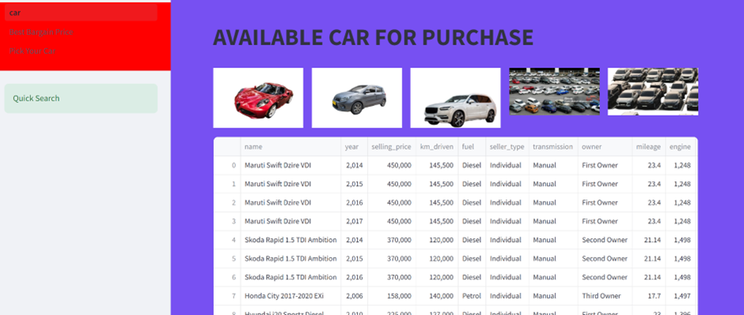

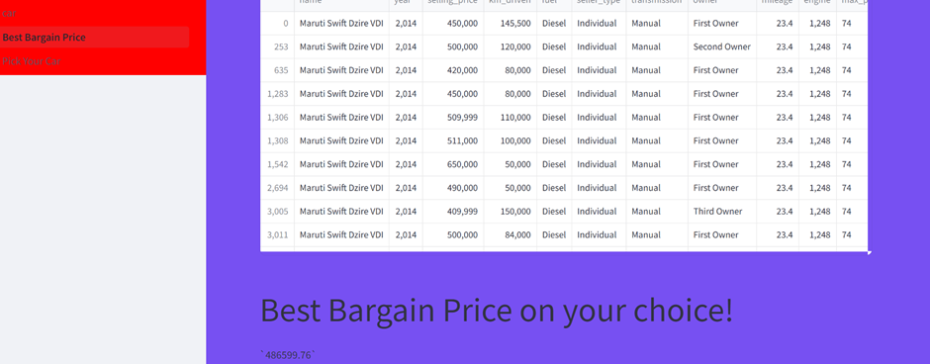

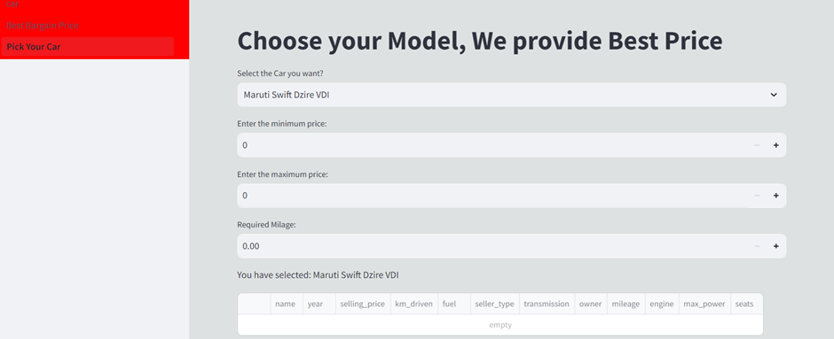

**CONCLUSION**

Developed Web Site to load Used Car information dataset on backend., present the avaible car for purchase to the users, by giving options to select different cars, compare with other Used Car Selling web sites. Using AI based solutions providing features to select better cars, to know the best bargained Price. To compete with emerging technologies, used Streamlit package to develop the entire web-site so that in future it is easy to integrate with additional AI supportive features. These systems offer detailed information about car features and models, assisting users in making informed decisions based on their preferences and budget. They effectively address inquiries related to vehicles, including technical issues and maintenance concerns, ensuring efficient customer support.

**FUTURE SCOPE**

Integrating Web Site with AI-powered Chabot, so that it gives additional future as one stop web site to access data related to available cars to purchase and knowing the different rules to follow while driving, access to Driving Licence Centers, Tyre Centers, Garage Centers near by location. Using AI Methodology we can predict a Cars bargain price by comparing with hundreds of such cars,

**REFERENCES**

1. <https://ieeexplore.ieee.org/document/10444919>
2. <https://flatirons.com/blog/ai-in-transportation-industries/>
3. <https://appinventiv.com/blog/ai-in-transportation/>
4. <https://syndelltech.com/ai-in-transportation/>
5. <https://www.scaler.com/topics/artificial-intelligence-tutorial/transportation-ai/>

[6. https://www.kaggle.com/datasets/sidharth178/car-prices-dataset](6.%20%20%20https://www.kaggle.com/datasets/sidharth178/car-prices-dataset)

**SOURCE CODE AND CONFIGURATION FILES**

1. Cardata.csv
2. Car.py
3. Best_Bargain_price.py
4. Pick_you_Car.py